Engine Mount Report:

**Introduction**:   
This report intends to research possible Engine Mount systems and outline the specific requirements that will allow it to pass FSAE scrutineering and for our car to be safe and reliable on the track. This work is essential in ensuring that the engine is kept safe from both the hardness of the swaying chassis when the car enters corners but also that the engine is kept in a good condition and that it does not hit the driver if it was to be dislodged from its compartment in the chassis.   
The engine mounts are the small devices that ensure this.

[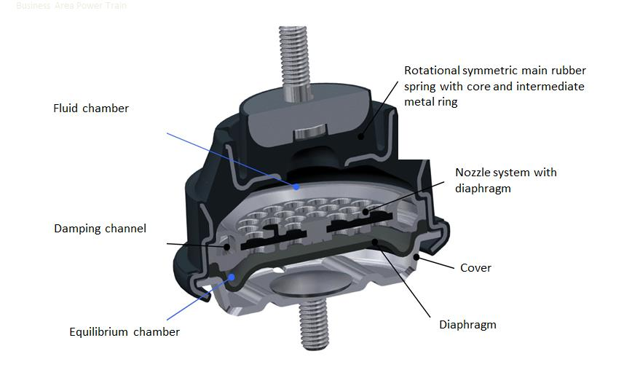](http://www.donohuereport.com/wp-content/uploads/2017/08/Engine-Mounts.jpg)**Theory**:   
Ideally used to completely cut off the driver from both the noise and vibration of the engine, the Engine Mounts act as shock absorbers to the vibrations of the Engine on the cars frame.   
There are many different types of Mounts, some, without any form of shock absorbing material like rubber or mechanisms like pneumatic actuators act to only hold the engine in place with no emphasis on protecting the driver from the sounds or vibrations of the Engine.   
This is unlike pneumatic Mounts like which can be seen below: (1)

Where the Fluid Chamber is in a pneumatic Mount, rubber can replace it, making the Mount cheaper and more reliable as there are less moving parts for it to encounter a problem. Research into Vibration Isolation Rubber from the frequency of vibrations of the Engine are easily accessible as this report extract for rubber shows how vibrations of an engine can be dampened by a rubber mount: (2) $f_{0}$  
= The Engines excitation force $a_{0}$ 
= The excitation amplitude of the ground   
F= The transmitted force to the ground  
a= The transmitted amplitude to the machine

Therefore:  
Vibration transmissibility

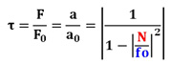  
  
**F1：Vibration Transmissibility Formula**  
N: Interference frequency (Hz) $f_{0}$ 
: Natural frequency (Hz)   
  
Figure.1 is a “vibration transmissibility curve". Vibration transmissibility is determined by the ratio between excitation frequency (=N Hz) and natural frequency (= $f_{0}$ Hz). If this value (N/ $f_{0}$ ratio) becomes 1, vibration will be resonated and amplified to an unlimited degree. In order to create an isolation effect, we carefully select the spring stiffness of the vibration isolation rubber and tune the N/ $f_{0}$ ratio above 1.4.

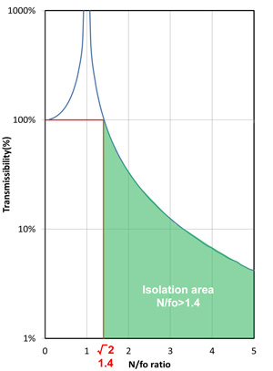

Figure 1. Magnification factor

Natural frequency

Natural frequency (= $f_{0}$) can be calculated by the following “Natural Frequency Formula” below:  
  
f1 formula  
  
: Natural frequency (Hz)  
K: Dynamic spring stiffness (N/mm)  
M: Weight of supported object (Kg)   
  
It also can be expressed as shown in the graph (Figure.2).  
  
If we know the static support weight and targeted natural frequency, we can project the required spring stiffness of a vibration isolation rubber mount using the graph below. (Generally speaking, the dynamic spring stiffness of a vibration isolation rubber mount is 1.2 to 1.4 times static spring stiffness.)

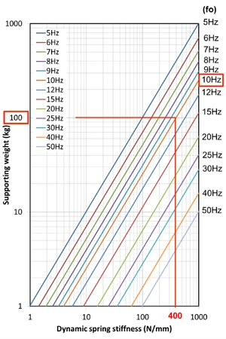

Figure 2. Natural freqency ($f_{0}$) chart

**Example:** Using the above graph, if the supporting weight per mount is 100kg and targeted natural frequency ($f_{0}$) is 10Hz, the required dynamic spring stiffness of the vibration isolation rubber mount becomes 400N/mm. The Dynamic Spring Stiffness of rubber is typically 1.2 to 1.4 higher than static spring stiffness, so in this case, the required static spring stiffness range is approximately 285 to 330N/mm

A “Sandwich” Mount:  
A simpler Mount that sports a sandwich feature of metal-rubber-metal format can be used to both save money and the mounts themselves easier to repair and fit onto the chassis and engine using the materials pictured below:

[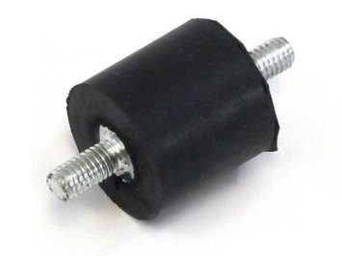](https://www.google.co.uk/url?sa=i&rct=j&q=&esrc=s&source=images&cd=&cad=rja&uact=8&ved=0ahUKEwjk4YTmwNXXAhWLshQKHXkwDxMQjRwIBw&url=https://guide.alibaba.com/Engine-Mounts_cid120231&psig=AOvVaw1QOqMI3v1kKJBTOb3t_uHq&ust=1511553547745347)[](https://www.google.co.uk/url?sa=i&rct=j&q=&esrc=s&source=images&cd=&cad=rja&uact=8&ved=0ahUKEwjYgfudv9XXAhVE0xQKHW9ZD04QjRwIBw&url=https://www.aliexpress.com/cheap/cheap-engine-mount-zenoah.html&psig=AOvVaw1QOqMI3v1kKJBTOb3t_uHq&ust=1511553547745347)

(4)

(3)

**Salford Practicability:**The above research, although useful, is more relevant to racing events like Formula 1 in which the rules are more stringent and the limits much tighter in the vibration, noise and heat transfer from the engine.   
However, due to the simplicity and future-sight that Salford Racing has to progress in future FSAE competitions, it will be a small and easy investment to buy an Engine Mount as detailed above.

**Conclusion:**Therefore, Salford Racing will be able to buy newly manufactured Engine Mounts for the Race car, enabling a higher specification of car equipment, relatively cheaper as the product Engineering that goes into making such a product is relatively simple which translates onto the customers whom it is cheaper for.  
The next stage of this process will be to measure the mounts that were previously used on the CAN-AM-DS450 Quad and purchase a new, suitable one in which we can use and fix onto the Race car, either using out-of-school welding or with fasteners. Dependant on the quality of the Fastener fixings, the welding is more likely to be a viable option, although more expensive, it will ensure stability with the engine in the Race car.

**Appendix**:  
(1) - <http://www.donohuereport.com/engine-mounts-market/>

(2) - <http://www.bridgestoneindustrial.com/products/vibration-isolation-rubber/VIR-theory.cfm>

(3) - <https://www.google.co.uk/url?sa=i&rct=j&q=&esrc=s&source=images&cd=&cad=rja&uact=8&ved=0ahUKEwjYgfudv9XXAhVE0xQKHW9ZD04QjRwIBw&url=https%3A%2F%2Fwww.aliexpress.com%2Fcheap%2Fcheap-engine-mount-zenoah.html&psig=AOvVaw1QOqMI3v1kKJBTOb3t_uHq&ust=1511553547745347>

(4) - <https://www.google.co.uk/url?sa=i&rct=j&q=&esrc=s&source=images&cd=&cad=rja&uact=8&ved=0ahUKEwjk4YTmwNXXAhWLshQKHXkwDxMQjRwIBw&url=https%3A%2F%2Fguide.alibaba.com%2FEngine-Mounts_cid120231&psig=AOvVaw1QOqMI3v1kKJBTOb3t_uHq&ust=1511553547745347>